Terraform Task

Task Description:

Launch Linux EC2 instances in two regions using a single Terraform file.

Techstacks needs to be used :

- AWS EC2
- Terraform
- AWS CLI

Before state of Ec2 instance in –region us-east-1:-

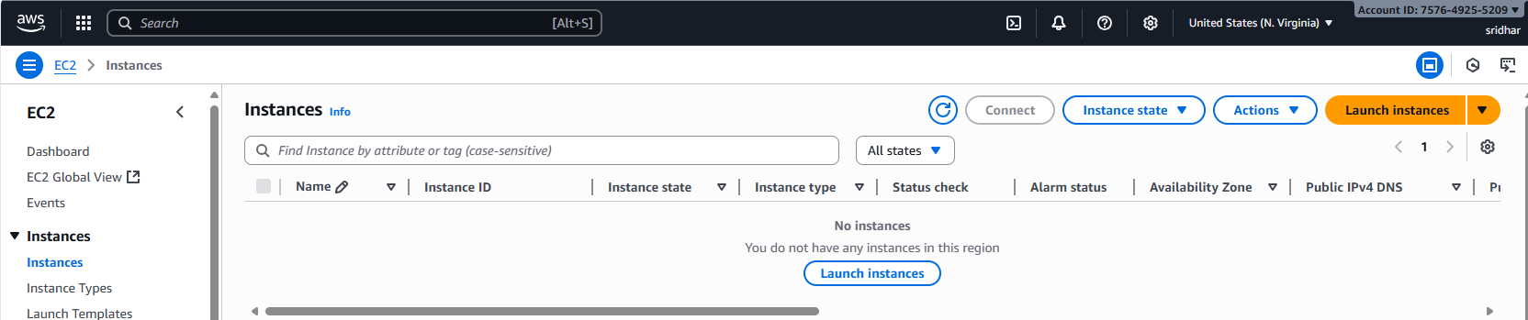
Before state of Ec2 instance in –region eu-west-1:-
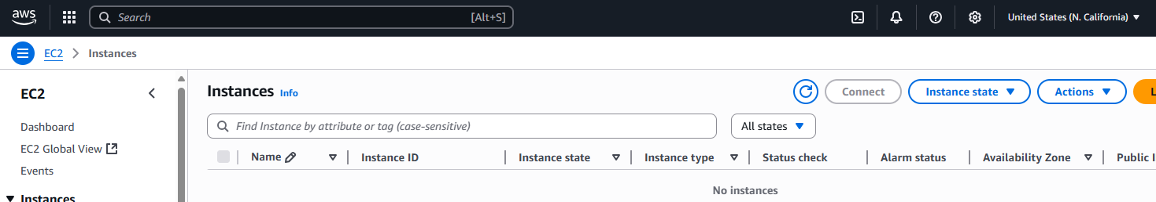
Terraform code for Launch Linux EC2 instances in two regions: -
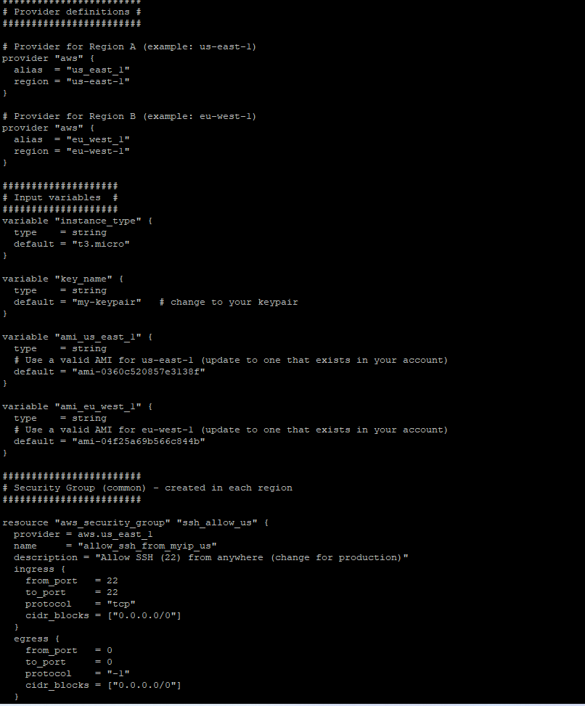
Terraform Plan: -
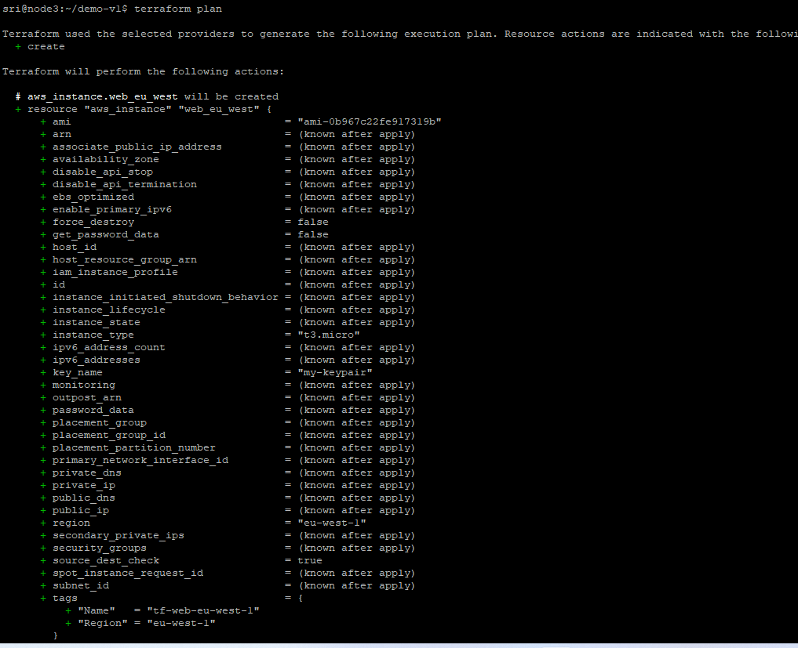
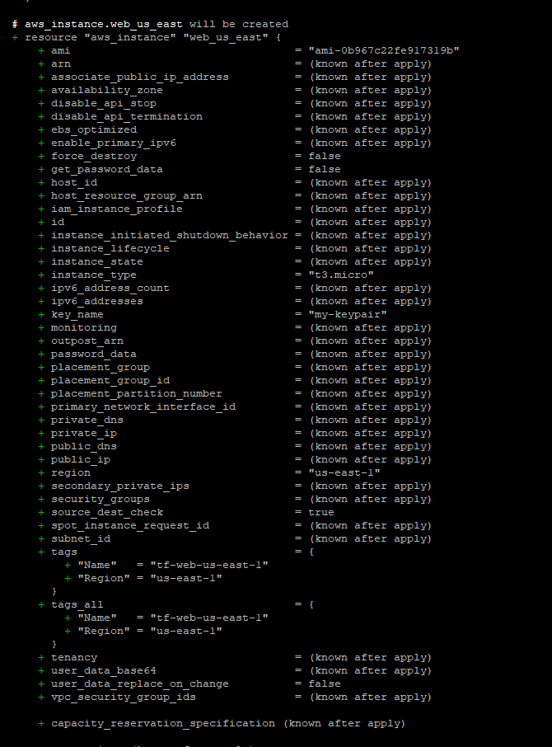
After Terraform apply: -
